CH5440W Assignment 1 Full
Individual Submissions; Submit a neat copy (handwritten or typed)
- Write the question number and subdivisions before the answer
- Suggested to do with Matlab/Excel/Python – Your choice
- Deadline: 23rd June 2026

Question 1 [2x11]
A new washing machine prototype is developed by a Company. It’s unique design enables efficient removal of dirt but at the same time it is felt that the color of the cloth also gets removed during the washing. Hence the washing machine is subject to some trials wherein the color in the wash liquid (C) is analyzed using a photometer. The variables considered while washing with good quality water are listed as follows.
1) Temperature of the water (X₁)
2) Amount of detergent powder (X₂)
The washing time is set for a standard 10-minute cycle.
It is assumed that the addition of powder does not induce additional heating or cooling of the water. The data collected are given below. The model to be considered is NOT known. Since the two variables are of different magnitudes it is better to code the variables as shown in Table 1. Consider a linear regression model involving the main effects X₁ and X₂ only.
NOTE: Give all formulae and matrices. Also provide code.

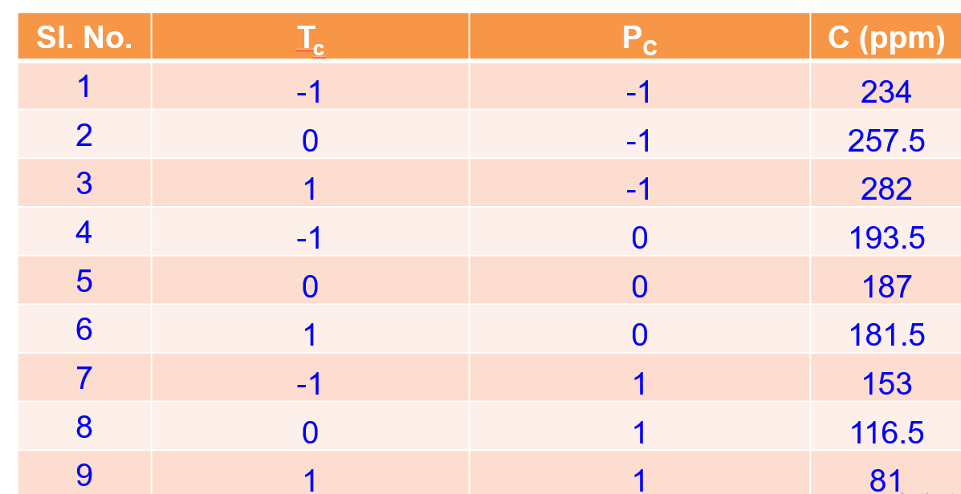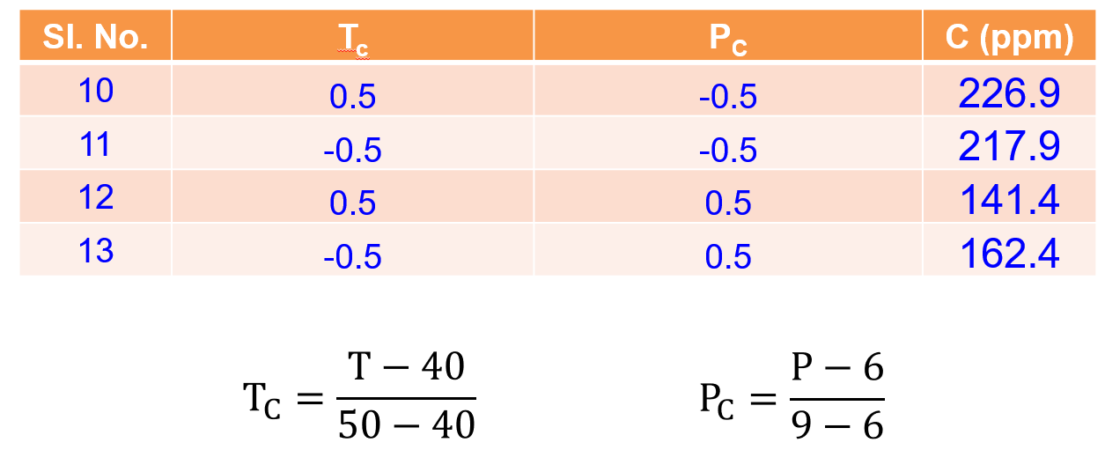

- Present the ${\left(X^{'}X\right)}^{-1}$ matrix
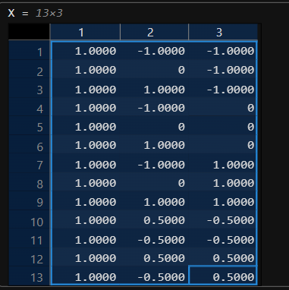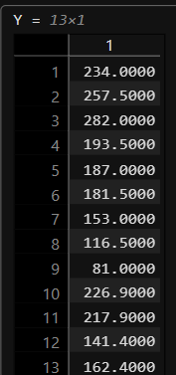
${(X'X)}^{-1}$ =
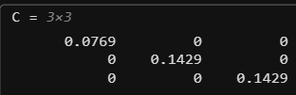
Find
- The least squares estimates of the parameters including intercept
$\hat{β} = {(X'X)}^{-1}(X'Y)$
$β_{0} = 187.2769$
$β_{1} = -6$
$β_{2} = -70.5$

- Compare actual values with model predicted values
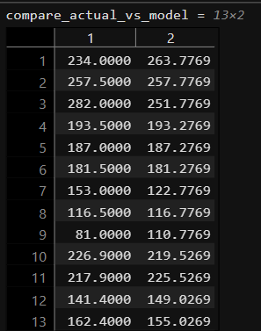

- the degrees of freedom for residual sum of squares
${df}_{Total} = n - 1 = 13 - 1 = 12$
${df}_{Residual} = n - p = 13 - 3 = 10$
${df}_{Regression} = p - 1 = 3 - 1 = 2$

- the estimated standard error of the least square estimators
${SS}_{E} = Y'Y - \hat{β}'X'Y = 3825.6$
$σ = \sqrt{\frac{{SS}_{E}}{{df}_{Residual}}} = 19.5591$
$Variance Covariance Matrix = {(X'X)}^{-1}σ^{2}$
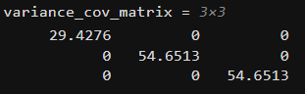
$Estimated Standard error of least square estimators:$ $\sqrt{{(X'X)}^{-1}σ^{2}}$
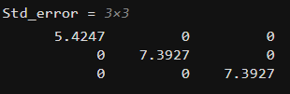

- the SS_{Total}, SS_{Residual}, and SS_{Regression} all corrected for the intercept
${SS}_{Total} = Y'Y - \frac{{(\sum_{i = 1}^{n}{Y_{i}})}^{2}}{n} =38869.34$
${SS}_{E} = {SS}_{Residual} = Y'Y - \hat{β}'X'Y = 3825.6$
${SS}_{Regression} ={SS}_{Total} - {SS}_{Residual} = 35043.75$

- R²
$$R^{2 } = \frac{{SS}_{Regression}}{{SS}_{Total}} = 0.9016$$
- adjusted R²
$$Adj R^{2 } = 1 - \frac{{SS}_{Residual}}{{SS}_{Total}}*\frac{{df}_{Total}}{{df}_{Residual}} =0.8819$$

- PRESS
$$H = X{*(X'X)}^{-1}*X'$$
$$E = \frac{(Y - \hat{Y})}{1 - diag(H)}$$
$$PRESS = \sum{E^{2}} = 9173.25$$

- R²_{PRESS}
$R_{PRESS}^{2} = 1 - \frac{PRESS}{{SS}_{Total}} = 0.7640$
Code must be provided.
Question 2 [3+2+5+2+3]
In a regression analysis, data was fitted in different ways to give different regression equations (Table 2). Find a. R² b. adj. R² c. PRESS d. R² based on PRESS.
Table 2. Regression Fits for a single independent variable x
Run | x | y | Runs included to find regression fit | Regression Equation
A | -1 | -5.1 | Only B & C | $$\hat{y}= -3.10+3.5x$$
B | 2 | 3.9 | Only A & C | $$\hat{y}= -1.975+3.125x$$
C | 3 | 7.4 | Only A and B | $$\hat{y}= -2.1+3x$$
 |  |  | All (1, 2 and 3) | $$\hat{y}= -2.062+3.0962x$$

Do you find R² and adjusted R² only for the full model including points A, B, and C or find them for models based on B&C only, A&C only and A&B only as well?
NOTE: Give all formulae. Code irrelevant.
Solution
a) The regression equation obtained using all three observations is
ŷ= −2.062 + 3.0962x

Point | x | Actual y | ŷ
A | -1 | -5.1 | -2.062+3.0962(-1)= -5.1582
B | 2 | 3.9 | -2.062+3.0962(2)= 4.1304
C | 3 | 7.4 | -2.062+3.0962(3)= 7.2266

Residual,
e_{i}=y_{i}− ŷ_{i}
Point | Residual (y - ŷ) | (y - ŷ)²
A | 0.0582 | 0.003387
B | -0.2304 | 0.053084
C | 0.1734 | 0.030068

Therefore,
SSE= (0.0582)²+(−0.2304)²+(0.1734)²
= 0.003387+0.053084+0.030068
= 0.086539

Calculate the Total Sum of Squares (SST)
First, calculate the mean of the observed values.
y bar= (−5.1+3.9+7.43)/3 =2.0667
Point | (y- y bar) | (y- y bar)²
A | -7.1667 | 51.3611
B | 1.8333 | 3.3611
C | 5.3333 | 28.4444

SST​= (−7.1667)²+(1.8333)²+(5.3333)²
= 51.3611+3.3611+28.4444
= 83.1666​

Calculate R²
R²=1−(SSE/SST)=
1−(0.086539/83.1666)
=1−0.001040
=0.99896

b) Calculation of Adjusted R²
R²_{adj}$=1-[(SSE/ (n-P-1))/(SST/(n-1)​)]$
Where,
SSE=0.086539 (from Part (a))
SST=83.1666 (from Part (a))
Number of observations, n=3
number of independent variables, p=1
Calculate the residual mean square
The denominator is
n−p−1= 3−1−1= 1
SSE/ (n−P-1) = 0.086539/1 ​=0.086539
Calculate the total mean square
The denominator is
n−1=3−1=2
Hence,
SST/n−1= 83.1666/2=41.5833
Calculate Adjusted R2R^2R2
Substituting into the formula,
R²_{adj}​ = 1- (0.086539/ 41.5833)
= 1- 0.002081
= 0.997919
c)
Calculation of PRESS
The Prediction Sum of Squares (PRESS) is calculated using
PRESS= $\sum_{i=1}^{n}{{\left(y_{i}-{\hat{y}}_{\left(i\right)}\right)}^{2}}$
Where
$y_{i}$ is observed value
${\hat{y}}_{\left(i\right)}$ is predicted value of the omitted observation using the regression model fitted without that observation.
Predict observation A using the model fitted with B and C
Regression equation: ŷ= −3.10+3.5x
For x= -1
$\hat{y}$=−3.10+3.5(-1)
= -3.10-3.5
=-6.60
Prediction error:
e_{i}=y_{i}− ŷ_{i}
= -5.1 – (-6.6) = 1.5
Squared prediction error:
e_{i}² = 1.5²= 2.25

Predict observation B using the model fitted with A and C
Regression equation: ŷ= −1.975+3.125x
For x= 2
$\hat{y}$= −1.975+3.125(2)
= −1.975+6.25
=4.275
Prediction error:
e_{i}=y_{i}− ŷ_{i}
=3.9−4.275=−0.375
Squared prediction error:
e_{i}² = (−0.375)²=0.140625

Predict observation C using the model fitted with A and B

Regression equation: ŷ= −2.1+3x
For x= 3
$\hat{y}$= −2.1+3(3)
=−2.1+9
=6.9​
Prediction error:
e_{i}=y_{i}− ŷ_{i}
= 7.4−6.9=0.5
Squared prediction error:
e_{i}² = (0.5)²=0.25
Point | Actual (y) | Predicted (\hat y_{(i)}) | Prediction Error | Squared Error
A | -5.1 | -6.6 | 1.5 | 2.25
B | 3.9 | 4.275 | -0.375 | 0.140625
C | 7.4 | 6.9 | 0.5 | 0.25
TOTAL |  |  |  | PRESS= 2.640625

- Calculate R²
The predicted coefficient of determination is calculated using
R²_{PRESS} =1−(PRESS/SST)
where
- PRESS=2.640625 (from Part (c))
- SST=83.1666 (from Part (a))
Substituting the values,
R²_{PRESS} = 1− (2.640625/83.1666)
=1−0.03175
=0.96825

Question 3 [2+2+5+3+4]
- Find the inverse of the following matrix A (use python/Matlab/…)
$$A=\left[1 -1 2 2 2 4 3 4 6 \right]$$
If you had difficulties in inverting this matrix, what is the reason?
Given the matrix:
$$A=\left[1 -1 2 2 2 4 3 4 6 \right]$$
Formula for Matrix Inverse:
The inverse of a square matrix A exists if and only if its determinant is non-zero ($detdet \left(A\right) ≠0$), and is given by:
$$A^{-1}=\frac{1}{det \left(A\right) }adj\left(A\right)$$

Let us calculate the determinant of $A$:
$$detdet \left(A\right) =1\left|2 4 4 6 \right|-\left(-1\right)\left|2 4 3 6 \right|+2\left|2 2 3 4 \right|$$
$$detdet \left(A\right) =1\left(12-16\right)+1\left(12-12\right)+2\left(8-6\right)$$
$detdet \left(A\right) =-4+0+4=0$ (1M)
Reason for Difficulties in Inverting Matrix $A$:
We cannot invert this matrix because its determinant is exactly zero $(detdet \left(A\right) =0$). A matrix with a determinant of zero is called a singular matrix or non-invertible matrix.
Looking closely at the columns of $A$, the third column is exactly twice the first column ($C_{3}=2C_{1}$):
$$\left[2 4 6 \right]=2\left[1 2 3 \right]$$
This linear dependence among columns makes the matrix singular, and thus an inverse does not exist. (1M)
Reason for Difficulties in Inverting Matrix $A$:
We cannot invert this matrix because its determinant is exactly zero $(detdet \left(A\right) =0$). A matrix with a determinant of zero is called a singular matrix or non-invertible matrix.
Looking closely at the columns of $A$, the third column is exactly twice the first column ($C_{3}=2C_{1}$):
$$\left[2 4 6 \right]=2\left[1 2 3 \right]$$
This linear dependence among columns makes the matrix singular, and thus an inverse does not exist. (1M)
- Also find the rank of the matrix. What do you understand by rank of the matrix?
What is the Rank of a Matrix?
The rank of a matrix is defined as the maximum number of linearly independent row vectors or column vectors contained within that matrix. It represents the dimension of the vector space spanned by its rows or columns. (1M)
Finding the Rank of $A$:
We can find the rank by reducing $A$ to row echelon form using elementary row operations:
- $R_{2}←R_{2}-2R_{1}$:
$$\left[1 -1 2 0 4 0 3 4 6 \right]$$
2. $R_{3}←R_{3}-3R_{1}$:

$$\left[1 -1 2 0 4 0 0 7 0 \right]$$
3. $R_{3}←R_{3}-\frac{7}{4}R_{2}$:
$$\left[1 -1 2 0 4 0 0 0 0 \right]$$
There are exactly 2 non-zero rows remaining in the row echelon form. Therefore, the rank of matrix $A$ is $2$. (1M)

- Is the following matrix B positive definite? If yes, show that it satisfies all the required properties including sign of eigenvalues.
$$B=\left[2 -1 0 -1 2 -1 0 -1 2 \right]$$
Given the symmetric matrix:
$$B=\left[2 -1 0 -1 2 -1 0 -1 2 \right]$$
A symmetric matrix is positive definite if all its eigenvalues are strictly positive or equivalently, if all its leading principal minors are strictly positive
1. Check Leading Principal Minors:
- First leading principal minor ($M_{1}$):
$$M_{1}=\left|2\right|=2>0$$
Second leading principal minor ($M_{2}$):
$$M_{2}=\left|2 -1 -1 2 \right|=\left(2\right)\left(2\right)-\left(-1\right)\left(-1\right)=4-1=3>0$$
Third leading principal minor ($M_{3}=detdet \left(B\right)$):
$$M_{3}=2\left|2 -1 -1 2 \right|-\left(-1\right)\left|-1 -1 0 2 \right|+0$$
$$M_{3}=2\left(4-1\right)+1\left(-2-0\right)=6-2=4>0$$
Since all leading principal minors ($2,3,4$) are strictly positive, matrix $B$ is positive definite. (3M)
2. Check Sign of Eigenvalues:
The characteristic equation is given by $detdet \left(B-λI\right) =0$:
$$\left|2-λ -1 0 -1 2-λ -1 0 -1 2-λ \right|=0$$
$$\left(2-λ\right)\left[{\left(2-λ\right)}^{2}-1\right]-\left(-1\right)\left[-\left(2-λ\right)\right]=0$$

$$\left(2-λ\right)\left(λ^{2}-4λ+3\right)-\left(2-λ\right)=0$$
$$\left(2-λ\right)\left(λ^{2}-4λ+2\right)=0$$
Solving this yields the three eigenvalues:
$$λ_{1}=2$$
$$λ_{2}=2+\sqrt{2}≈3.4142$$

$$λ_{3}=2-\sqrt{2}≈0.5858$$
Since all eigenvalues are strictly positive ($λ_{i}>0$), it satisfies the eigenvalue condition for positive definiteness. (2M)

- What are idempotent matrices? Is the following matrix idempotent?
$$C=\left[2 -2 -4 -1 3 4 1 -2 -3 \right]$$
Definition:
An idempotent matrix is a square matrix which, when multiplied by itself, remains unchanged. Mathematically, a matrix $C$ is idempotent if and only if:
$C^{2}=C×C=C$ (1M)
Given the matrix:
$$C=\left[2 -2 -4 -1 3 4 1 -2 -3 \right]$$
Let us compute $C^{2}$:
$$C^{2}=\left[2 -2 -4 -1 3 4 1 -2 -3 \right]\left[2 -2 -4 -1 3 4 1 -2 -3 \right]$$
Evaluating element by element:
- Row 1:
$\left(2\right)\left(2\right)+\left(-2\right)\left(-1\right)+\left(-4\right)\left(1\right)=4+2-4=2$
$$\left(2\right)\left(-2\right)+\left(-2\right)\left(3\right)+\left(-4\right)\left(-2\right)=-4-6+8=-2$$
$$\left(2\right)\left(-4\right)+\left(-2\right)\left(4\right)+\left(-4\right)\left(-3\right)=-8-8+12=-4$$
- Row 2:
$$\left(-1\right)\left(2\right)+\left(3\right)\left(-1\right)+\left(4\right)\left(1\right)=-2-3+4=-1$$
$$\left(-1\right)\left(-2\right)+\left(3\right)\left(3\right)+\left(4\right)\left(-2\right)=2+9-8=3$$
$$\left(-1\right)\left(-4\right)+\left(3\right)\left(4\right)+\left(4\right)\left(-3\right)=4+12-12=4$$
- Row 3:
$$\left(1\right)\left(2\right)+\left(-2\right)\left(-1\right)+\left(-3\right)\left(1\right)=2+2-3=1$$
$$\left(1\right)\left(-2\right)+\left(-2\right)\left(3\right)+\left(-3\right)\left(-2\right)=-2-6+6=-2$$
$$\left(1\right)\left(-4\right)+\left(-2\right)\left(4\right)+\left(-3\right)\left(-3\right)=-4-8+9=-3$$
Thus:
$$C^{2}=\left[2 -2 -4 -1 3 4 1 -2 -3 \right]=C$$
Yes, matrix $C$ is idempotent. (2M)

- Show that the matrix x obtained as follows is both orthogonal and orthonormal. Also show that $xx^{'}=I$
$$x= \left[0.2534 -0.9674 0.9674 0.2534 \right]$$
Given the matrix:
$$x=\left[0.2534 -0.9674 0.9674 0.2534 \right]$$
Definitions:
Orthogonal columns/rows: The dot product of distinct rows/columns must be zero.
Orthonormal columns/rows: The vectors must be orthogonal and each must have a unit length (norm = 1).
Orthogonal Matrix Condition: $xx^{T}=I$ (where $x^{T}$ is the transpose of $x$).
- Showing Orthogonality: (1M)
Let's find the dot product of Row 1 and Row 2:
$${Row}_{1}⋅{Row}_{2}=\left(0.2534\right)\left(0.9674\right)+\left(-0.9674\right)\left(0.2534\right)=0.24513916-0.24513916=0$$
Since the dot product is zero, the row vectors are orthogonal.
- Showing Orthonormality (Unit Norm): (1M)
Let's find the magnitude (norm) of the rows:
$${‖{Row}_{1}‖}^{2}={\left(0.2534\right)}^{2}+{\left(-0.9674\right)}^{2}=0.06421156+0.93586276=1.00007432≈1{‖{Row}_{2}‖}^{2}={\left(0.9674\right)}^{2}+{\left(0.2534\right)}^{2}=0.93586276+0.06421156=1.00007432≈1$$
(Note: The slight deviation from exactly 1 is purely due to the 4 decimal-place rounding of the given matrix constants).

Since the vectors are orthogonal and have a norm of $1$, the matrix is orthonormal.

- Showing $xx^{T}=I$: (2M)
$$x^{T}=\left[0.2534 0.9674 -0.9674 0.2534 \right]$$
$$xx^{T}=\left[0.2534 -0.9674 0.9674 0.2534 \right]\left[0.2534 0.9674 -0.9674 0.2534 \right]$$

$$xx^{T}=\left[{\left(0.2534\right)}^{2}+{\left(-0.9674\right)}^{2} \left(0.2534\right)\left(0.9674\right)+\left(-0.9674\right)\left(0.2534\right) \left(0.9674\right)\left(0.2534\right)+\left(0.2534\right)\left(-0.9674\right) {\left(0.9674\right)}^{2}+{\left(0.2534\right)}^{2} \right]$$
$$xx^{T}≈\left[1 0 0 1 \right]=I$$

NOTE: Give all formulae and matrices. Also provide code
Question 4 [5+5]
The Cholesky decomposition factorizes a Hermitian, positive-definite matrix A into the product of a lower triangular matrix L and its conjugate transpose L* (or L′) for real matrices), such that A = LL* or LL′. It is roughly twice as fast as LU decomposition and requires half the storage

- For the matrix given below can you do Cholesky Decomposition? If yes, what are the required criteria and the outcomes of the decomposition?

$$A=\left[4 12 -16 12 37 -43 -16 -43 98 \right]$$

Please do the calculations by hand and confirm with Python/Matlab
- Criteria for Cholesky Decomposition

To perform Cholesky decomposition ($A=LL^{T}$), the matrix $A$ must meet two criteria:
- It must be symmetric ($A=A^{T}$). Looking at $A$: $A_{12}=A_{21}=12$, $A_{13}=A_{31}=-16$, and $A_{23}=A_{32}=-43$. This holds true.
- It must be positive-definite (all leading principal minors must be strictly positive). Let's verify:
$$M_{1}=\left|4\right|=4>0$$

$$M_{2}=\left|4 12 12 37 \right|=148-144=4>0$$

$$M_{3}=detdet \left(A\right) =4\left(37⋅98-{\left(-43\right)}^{2}\right)-12\left(12⋅98-\left(-43\right)\left(-16\right)\right)+\left(-16\right)\left(12⋅\left(-43\right)-37⋅\left(-16\right)\right)=36>0$$

Since both criteria are met, yes, Cholesky Decomposition is completely valid.

- Hand Calculation for Cholesky ($A=LL^{T}$)
Let $L$ be a lower triangular matrix:

$$L=\left[l_{11} 0 0 l_{21} l_{22} 0 l_{31} l_{32} l_{33} \right]$$
Equating elements of $A=LL^{T}$:

$$\left[4 12 -16 12 37 -43 -16 -43 98 \right]=\left[l_{11}^{2} l_{11}l_{21} l_{11}l_{31} l_{21}l_{11} l_{21}^{2}+l_{22}^{2} l_{21}l_{31}+l_{22}l_{32} l_{31}l_{11} l_{31}l_{21}+l_{32}l_{22} l_{31}^{2}+l_{32}^{2}+l_{33}^{2} \right]$$
Row 1 Calculations:
$$l_{11}^{2}=4⟹l_{11}=2$$

$$l_{11}l_{21}=12⟹2\left(l_{21}\right)=12⟹l_{21}=6$$

$$l_{11}l_{31}=-16⟹2\left(l_{31}\right)=-16⟹l_{31}=-8$$

Row 2 Calculations:

$$l_{21}^{2}+l_{22}^{2}=37⟹6^{2}+l_{22}^{2}=37⟹36+l_{22}^{2}=37⟹l_{22}^{2}=1⟹l_{22}=1$$

$$l_{21}l_{31}+l_{22}l_{32}=-43⟹\left(6\right)\left(-8\right)+\left(1\right)\left(l_{32}\right)=-43⟹-48+l_{32}=-43⟹l_{32}=5$$

Row 3 Calculations:

$$l_{31}^{2}+l_{32}^{2}+l_{33}^{2}=98⟹{\left(-8\right)}^{2}+{\left(5\right)}^{2}+l_{33}^{2}=98⟹64+25+l_{33}^{2}=98⟹89+l_{33}^{2}=98⟹l_{33}^{2}=9⟹l_{33}=3$$

Outcome Matrix $L$:
$$L=\left[2 0 0 6 1 0 -8 5 3 \right]$$

- For the matrix given below do the LU Decomposition? Is the result same as that of the Cholesky Decomposition?

$$A=\left[4 12 -16 12 37 -43 -16 -43 98 \right]$$

Please do the calculations by hand and confirm with Python/Matlab
- Hand Calculation for LU Decomposition ($A=LU$) using Doolittle’s Algorithm

Where $L$ is a unit lower triangular matrix ($l_{ii}=1$) and $U$ is an upper triangular matrix:

$$L=\left[1 0 0 l_{21} 1 0 l_{31} l_{32} 1 \right], U=\left[u_{11} u_{12} u_{13} 0 u_{22} u_{23} 0 0 u_{33} \right]$$

Multiplying $L$ and $U$ and equating to $A$:

$$\left[1 0 0 l_{21} 1 0 l_{31} l_{32} 1 \right]\left[u_{11} u_{12} u_{13} 0 u_{22} u_{23} 0 0 u_{33} \right]=\left[4 12 -16 12 37 -43 -16 -43 98 \right]$$

Row 1 of $U$:

$$u_{11}=4, u_{12}=12, u_{13}=-16$$

Row 2 Elements:

$$l_{21}u_{11}=12⟹l_{21}\left(4\right)=12⟹l_{21}=3$$

$$l_{21}u_{12}+u_{22}=37⟹\left(3\right)\left(12\right)+u_{22}=37⟹36+u_{22}=37⟹u_{22}=1$$

$$l_{21}u_{13}+u_{23}=-43⟹\left(3\right)\left(-16\right)+u_{23}=-43⟹-48+u_{23}=-43⟹u_{23}=5$$

Row 3 Elements:

$$l_{31}u_{11}=-16⟹l_{31}\left(4\right)=-16⟹l_{31}=-4$$

$$l_{31}u_{12}+l_{32}u_{22}=-43⟹\left(-4\right)\left(12\right)+l_{32}\left(1\right)=-43⟹-48+l_{32}=-43⟹l_{32}=5$$

$$l_{31}u_{13}+l_{32}u_{23}+u_{33}=98⟹\left(-4\right)\left(-16\right)+\left(5\right)\left(5\right)+u_{33}=98⟹64+25+u_{33}=98⟹89+u_{33}=98⟹u_{33}=9$$

Outcome Matrices:

$$L_{LU}=\left[1 0 0 3 1 0 -4 5 1 \right], U_{LU}=\left[4 12 -16 0 1 5 0 0 9 \right]$$

- Is the result the same as Cholesky?

No, the resulting matrices are not identical

NOTE: Give all formulae and matrices. Also provide code
Question 5 [2x3+6+4+4]
Reference: Kutner, M. H., C. J. Nachtschiem, J. Netner, Applied Linear Regression Models. 4th ed. New Delhi: McGraw Hill, 2004.
A researcher studied the effects of the charge rate and temperature on the life of a new type of power cell in a preliminary small-scale experiment. The charge rate (X₁) was controlled at three levels (0.6, 1.0, and 1.4 amperes) and the ambient temperature (X₂) was controlled at three levels (10, 20, 30°C). Factors pertaining to the discharge of the power cell were held at fixed levels. The life of the power cell (Y) was measured in terms of the number of discharge-charge cycles that a power cell underwent before it failed. The data obtained in the study are given below:
Lifecycle (Y) | Charge Rate (X₁) | Temperature (X₂)
144 | 0.6 | 10
89 | 1.0 | 10
59 | 1.4 | 10
278 | 0.6 | 20
167 | 1.0 | 20
141 | 1.0 | 20
164 | 1.0 | 20
129 | 1.4 | 20
259 | 0.6 | 30
245 | 1.0 | 30
214 | 1.4 | 30
The researcher was not sure about the nature of the response function in the range of the factors studied. Hence, the researcher decided to fit the second-order polynomial regression model as $Y_{i}= β_{0}+ β_{1}x_{\left\{i1\right\}}+ β_{2}x_{\left\{i2\right\}}+ β_{\left\{11\right\}}x_{\left\{i1\right\}}^{2}+ β_{\left\{22\right\}}x_{\left\{i2\right\}}^{2}+ β_{\left\{12\right\}}x_{\left\{i1\right\}}x_{\left\{i2\right\}}+ ε_{i}$ (1)
So we have to find the six estimated parameters of the above model.
Write a code (using R/Python/MATLAB) to find the following:
i. Create a matrix “X” for raw data
The design matrix for the second-order polynomial model is
X= [1 X₁ X₂ X1² X2² X₁X₂]

clear all;
clc;

Data = [
144 0.6 10
89 1.0 10
59 1.4 10
278 0.6 20
167 1.0 20
141 1.0 20
164 1.0 20
129 1.4 20
259 0.6 30
245 1.0 30
214 1.4 30
];

Lifecycle=Data(:,1);
Chargerate=Data(:,2);
Temperature=Data(:,3);

Y=Lifecycle;
X1=Chargerate;
X2=Temperature;

% i. Create the design matrix X for the raw data
X = [ones(numel(X1),1) X1 X2 X1.^2 X2.^2 X1.*X2];
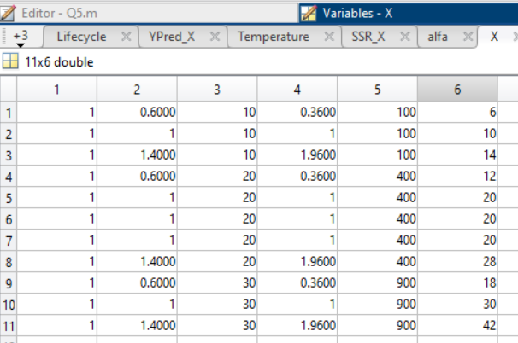

ii. Create a matric “z” such that $z= \frac{X-μ}{\left(X\right) -min⁡(X)}$
The transformed variables are obtained using
$= \frac{X-μ}{\max\left(X\right)-min⁡(X)}$
where μ is the mean of the respective predictor.
The transformed design matrix is
Z= [1 z₁ z₂ z1² z2² z₁z₂]

% ii. Create a matric “z”
z1=(X1-mean(X1))/(max(X1) - min(X1));
z2=(X2-mean(X2))/(max(X2) - min(X2));

Z=[ones(numel(z1),1) z1 z2 z1.^2 z2.^2 z1.*z2];

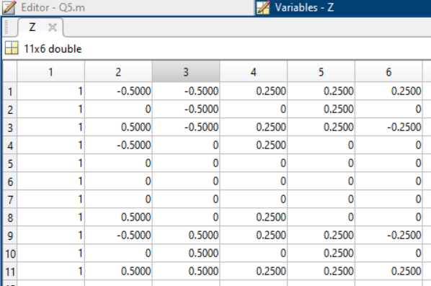

iii. Find regression coefficients for the two different cases (X, and z).
The least-squares estimate of the regression coefficients is
$\hat{β}={\left(X^{T}X\right)}^{-1}X^{T}Y$
For the transformed variables,
$\hat{β}={\left(Z^{T}Z\right)}^{-1}Z^{T}Y$

% iii. Find regression coefficients for the two different cases (X, and z).
betahat_X=(inv(X'*X))*(X'*Y);
betahat_Z=(inv(Z'*Z))*(Z'*Y);
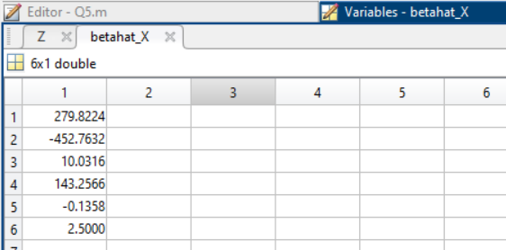
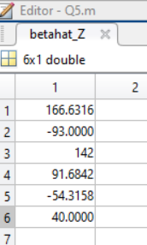

iv. Find residual sum of squares, regression sum of squares, total sum of squares. Use both Matrix and summation approaches and compare them. Do the values change depending upon the transformation?
Matrix approach:
$$SSE={\left(Y-\hat{Y}\right)}^{T}\left(Y-\hat{Y}\right)$$
Summation approach:
$$SSE=\sum_{i=1}^{n}{{\left(Y_{i}-{\hat{Y}}_{i}\right)}^{2}}$$
Total and regression sum of squares
$$SST=\sum_{i=1}^{n}{{\left(Y_{i}-\overline{Y}\right)}^{2}}$$
SSR = SST – SSE
% iv. Find residual sum of squares, regression sum of squares, total sum of squares. Use
% both Matrix and summation approaches and compare them. Do the values change
% depending upon the transformation?

% Predicted response
YPred_X=X*betahat_X;
YPred_Z=Z*betahat_Z;

% SSE using the matrix approach
Res_SSQ1_X=(Y-X*betahat_X)'*(Y-X*betahat_X);
Res_SSQ1_Z=(Y-Z*betahat_Z)'*(Y-Z*betahat_Z);

% SSE using the summation approach
Res_SSQ2_X=0;
Res_SSQ2_Z=0;

for i=1:numel(Y)
Res_SSQ2_X=Res_SSQ2_X+(Y(i)-YPred_X(i))^2;
Res_SSQ2_Z=Res_SSQ2_Z+(Y(i)-YPred_Z(i))^2;
end

% Total Sum of Squares (SST)
SST = Y'*Y - numel(Y)*(mean(Y))^2;

% Regression Sum of Squares (SSR)
SSR_X = SST - Res_SSQ2_X;
SSR_Z = SST - Res_SSQ2_Z;

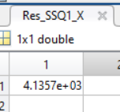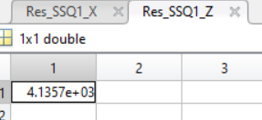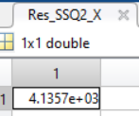
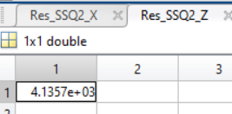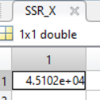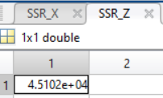
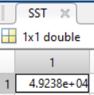
Comparison: The matrix and summation approaches produce identical values (except for negligible numerical round-off). The transformation does not change SSE, or SSR.

v. Find the variance-covariance matrix in both cases and compare the matrices for the transformed(z) and non-transformed (X) cases. Which is better in terms of precision of the regression coefficient estimates?
The estimate of the error variance is
$${\hat{σ}}^{2}=SSE/(n-p)$$
The variance-covariance matrix is
$$Var\left(\hat{β}\right)={\hat{σ}}^{2}{\left(X^{T}X\right)}^{-1}$$
For the transformed variables,
$$Var\left(\hat{β}\right)={\hat{σ}}^{2}{\left(Z^{T}Z\right)}^{-1}$$

% v. Find the variance-covariance matrix in both cases and compare the matrices for the
% transformed(z) and non-transformed (X) cases. Which is better in terms of precision of
% the regression coefficient estimates?

p=size(betahat_X,1); % verify if total number of parameters = 6
dof_Res = numel(X1)-p; % n-p

% Computing estimate of error variance using mean square residual
sigma_hat_X2=Res_SSQ2_X/dof_Res;
sigma_hat_Z2=Res_SSQ2_Z/dof_Res;

% Variance-Covariance Matrix based on X and Z data
Var_beta_X=inv(X'*X)*sigma_hat_X2; %Variance-Covariance Matrix based on X data
Var_beta_Z=inv(Z'*Z)*sigma_hat_Z2; %Variance-Covariance Matrix based on Z data

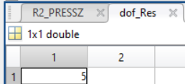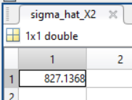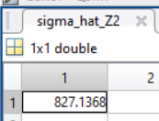
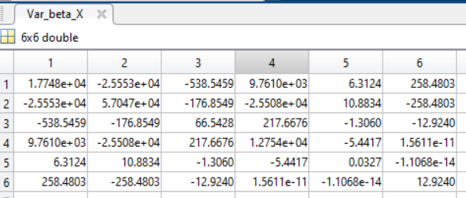
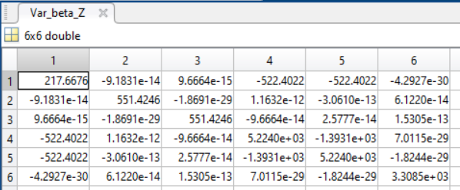

Comparison: The transformed variables provide improved numerical stability and smaller off-diagonal covariance terms, indicating reduced multicollinearity and more precise coefficient estimates.
vi. Find R², adj. R², PRESS, R² _{PRESS} for both the cases
NOTE: Give all formulae and matrices. Also provide code
The coefficient of determination is
R²=1−(SSE/SST)
The adjusted coefficient of determination is
R²_{adj}​=1−[(SSE/ (n−P))/(SST/(n−1)​)] (P is the total no. of regression coefficients)
The Prediction Sum of Squares is
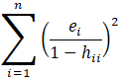
The predicted coefficient of determination is
R²_{PRESS}​= 1- (PRESS/SST)
% vi. Find R2, adj. R2, PRESS, R2 PRESS for both the cases

% Coefficient of Determination R^2
R2_X=1-Res_SSQ2_X/(Y'*Y-numel(X1)*(mean(Y))^2);
R2_Z=1-Res_SSQ2_Z/(Y'*Y-numel(z1)*(mean(Y))^2);

% H Matrices
HX=X*(inv(X'*X))*X';
HZ=Z*(inv(Z'*Z))*Z';

PRESS_X=0;
PRESS_Z=0;

for i= 1: numel(Y)
PRESS_X=PRESS_X + ((Y(i)-YPred_X(i))/(1-HX(i,i)))^2;
PRESS_Z=PRESS_Z + ((Y(i)-YPred_Z(i))/(1-HZ(i,i)))^2;
end

% Coefficient of determination based on PRESS
R2_PRESSX=1-PRESS_X/(Y'*Y-numel(X1)*(mean(Y))^2);
R2_PRESSZ=1-PRESS_Z/(Y'*Y-numel(z1)*(mean(Y))^2);

% Adjusted R^2
MeanSq_Res_X=Res_SSQ2_X/(numel(X1)-p);
MeanSq_Res_Z=Res_SSQ2_Z/(numel(z1)-p);
MeanSq_Total=(Y'*Y-numel(X1)*(mean(Y))^2)/(numel(X1)-1);

AdjR2_X=1-MeanSq_Res_X/MeanSq_Total;
AdjR2_Z=1-MeanSq_Res_Z/MeanSq_Total;

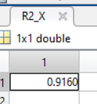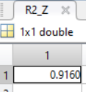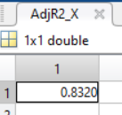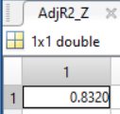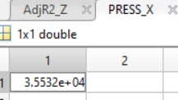
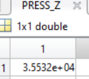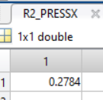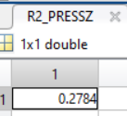

Question 6 [2+3+2+5+2]
Take any dataset pertaining to your discipline that involves numerical and categorical predictors (at least one each) and one numerical response variable. If you are unable to find an example/exercise, invent one on your own.
Do a linear regression problem involving both numerical and categorical predictors using two methods
- Using one hot encoding (OHE) with intercept removed and present the X matrix
- Run the regression based on OHE and present the results (estimated parameters, comparison with predicted values)
- Show the dummy variable trap if you had retained the intercept
- Using dummy variables where intercept is allowed carry out the regression and present the results
- Show how you created dummy variables from OHE variables
NOTE: Give all formulae and matrices. Also provide code
Solution: Grade based on the students' submitted dataset and code

Question 7 [6]
The following sample (n= 12) is collected from a population. Obtain its first quartile, second quartile (median) and the third quartile values. Also obtain the mean, standard deviation and variance.
10, 12, 11, 9, 9, 10, 11, 12, 11, 10, 11, 12
Solution

Quartiles:
Splitting into Halves

First Quartile ($Q_{1}$): The median of the lower half = 10
Second Quartile ($Q_{2}$ / Median): The median of the entire dataset = 11
Third Quartile ($Q_{3}$): The median of the upper half = 11.5
Mean, std and variance:
Mean
$$\underline{x}=\frac{\sum{}x_{i}}{n} = 10.67$$
Sample Variance
$$s^{2}=\frac{\sum{}{\left(x_{i}-\underline{x}\right)}^{2}}{n-1}=\frac{12.6667}{11}≈1.1515$$
Sample Standard deviation
$$s=\sqrt{s^{2}}=\sqrt{1.1515}≈1.0731$$

Question 8 [5]
Experiments labelled E1 to E6 were performed on plant species A and B. The experiments comprised of adding saltwater (0-250 mg/L). The initial plant heights were noted and their growth in terms of increase in height was monitored. The wilting of the plant was monitored using a scale between 0 and 10. The plants that survived was denoted 1 and those which died was denoted 0.
Make a schematic table based on the above information including Experiment ID, plant species, concentration of salt, initial height, growth, wilting and survival.
Identify the types of variables in this table.
Schematic data table with hypothetical data
Experiment ID | Plant Species | Salt Concentration (mg/L) | Initial Height (cm) | Growth (cm) | Wilting Score (0–10) | Survival
E1 | A | 0 | 12.5 | 8.2 | 0 | 1
E2 | A | 50 | 13.1 | 6.9 | 2 | 1
E3 | A | 100 | 12.8 | 5.1 | 4 | 1
E4 | B | 150 | 11.9 | 3.7 | 6 | 1
E5 | B | 200 | 12.3 | 1.8 | 8 | 0
E6 | B | 250 | 12.7 | 0.4 | 10 | 0

Logic used to fill the table
- Experiment ID: Sequentially assigned from E1 to E6.
- Plant Species: First three experiments use Species A and the last three use Species B.
- Salt Concentration: Selected within the specified range (0–250 mg/L) with increasing concentrations.
- Initial Height: Chosen randomly between approximately 12–13 cm, representing natural variation before treatment.
- Growth: Assumed to decrease with increasing salt concentration due to salt stress.
- Wilting Score: Assumed to increase as salt concentration increases (0 = no wilting, 10 = complete wilting).
- Survival: Plants with lower wilting scores are assumed to survive (1), whereas plants subjected to the highest salt concentrations with severe wilting are assumed not to survive (0).
Variable | Type of Variable
Experiment ID | Identifier (Nominal)
Plant Species | Categorical
Salt Concentration (mg/L) | Numerical
Initial Height (cm) | Numerical
Growth (cm) | Numerical
Wilting Score (0–10) | Ordinal (categorical)
Survival (0 = Dead, 1 = Survived) | Binary Categorical

Question 9 [8]
Let us say that you come across the following data set. You want to identify the outliers in this data set.
180 156 9 176 163 1827 166 171
Identify the outlier(s) using the following means
- Visual inspection
Data = [ 9 156 163 166 171 176 180 1827]
9, 1827 on both ends seem to be as outliers

- Drawing figures – for e.g. box plot
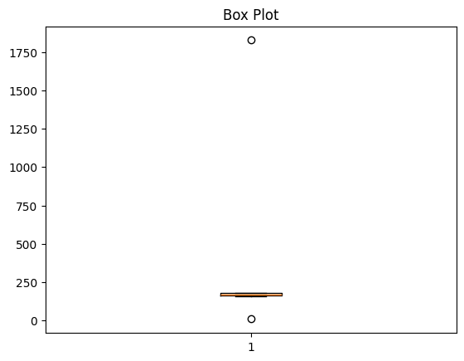

- Using interquartile range
Data = [ 9 156 163 166 171 176 180 1827]
Note : For Q1 and Q2 different formulas can be taken, as long as the formulae used by students is correct, marks will be provided.
$Q_{1} = median of first half = \frac{(156 + 163)}{2} = 159.5$
$$Q_{3} = median of second half = \frac{(176 + 180)}{2} = 178$$
$${IQR = Q}_{3} - Q_{1} = 18.5$$
$$Lower Bound = Q_{1} - 1.5*IQR = 131.75$$
$$Upper Bound = Q_{3} + 1.5*IQR = 205.75$$
Therefore, Outliers are points < LB and points > UB = 9, 1827

- Assume a normal distribution and find z-scores. An z score >3 or <-3 indicates the presence of an outlier
$Mean, μ = mean(data) = 356$
$Standard Deviation, σ = 597.0403$
$z = \frac{(x - μ)}{σ}$
$z =[-0.295,-0.335,-0.581,-0.301,-0.323, 2.464 ,-0.318,-0.310]$
Since there are no points satisfying either z > 3 or z < -3 = > no outliers assuming normal distribution.
Question 10 [9]
For the data presented in Table below, find the missing values and provide justification for the methods you used to estimate them. Compare your method(s) with moving mean technique (5 point window about each of the missing values)
Table Q10. Handling Missing Data
Sl. No. | X | Y | Z
1 | 0 | 3 | 0
2 | 1 | 5 | 1
3 | 3 | ? | 9
4 | 6 | 15 | ?
5 | 8 | 19 | 64
6 | 9 | ? | 81
7 | 10 | 23 | 100
8 | 12 | 27 | 144
Solution:
Missing values (via regression)
Checking the known data first:
- Y = 2X + 3 — fits all known points exactly (R² = 1)
- Z = X² — fits all known points exactly (R² = 1)
Since these hold exactly, regression is used (not averaging):
Sno | X | Y | Y = 2X + 3 | Z | Z = X^2
1 | 0 | 3 | 3 | 0 | 0
2 | 1 | 5 | 5 | 1 | 1
3 | 3 | ? = y1 |  | 9 | 9
4 | 6 | 15 | 15 | ? = z1
5 | 8 | 19 | 19 | 64 | 64
6 | 9 | ? = y2 |  | 81 | 81
7 | 10 | 23 | 23 | 100 | 100
8 | 12 | 27 | 27 | 144 | 144
Missing | X | Formula | Value
y1 | 3 | 2(3)+3 | 9
z1 | 6 | 6² | 36
y2 | 9 | 2(9)+3 | 21
Moving mean (5-point window)
- y1 = (3+5+15+19)/4 = 10.5
- z1 = (1+9+64+81)/4 = 38.75
- y2 = (15+19+23+27)/4 = 21
Comparison
Value | Regression | Moving mean | True value | MM error
y1 | 9 | 10.5 | 9 | 1.5
z1 | 36 | 38.75 | 36 | 2.75
y2 | 21 | 21 | 21 | 0

MM error = |Moving mean estimate − True value|
Justification & conclusion
Regression is correct here because the data follows an exact functional relationship (Y linear in X, Z quadratic in X, both R²=1) — it's not noisy scatter, so fitting the curve recovers the true value with zero error. The moving mean, by contrast, only locally averages neighbouring points; it ignores the curvature of Z=X² and the linear trend in Y, introducing avoidable error (1.5 for y1, 2.75 for z1). It matches exactly for y2 only by coincidence, since the 4 neighbouring Y-points are symmetric about X=9 on a straight line. Moving mean is a reasonable fallback when no functional relationship is known, but regression is the appropriate choice whenever such a relationship can be established, as it is here.
Question 11 [10]
Match the following in the table given below (more than one pair up is possible)

Variable type | Examples
- Nominal | - <50,000; 50000-100000; >100000 (in Rs.)
- Ordinal | - pH
- Interval | - Reaction rate
- Ratio | - PIN code
 | - Genotype
 | - Temperature scale in Rankine (ºR)
 | - scale of years AD (Anno Domini)
 | - Calendar dates
 | - Shoe size
 | - Pulse rate
 | - F1 race car speed
 | - Education : BSc, MSc, MPhil

Solution
(A) Nominal(IV) PIN code, (V) Genotype

(B) Ordinal(I) <50,000; 50000-100000; >100000, (XII) Education: BSc, MSc, MPhil

(C) Interval(II) pH, (VII) Scale of years AD, (VIII) Calendar dates, (IX) Shoe size

(D) Ratio(III) Reaction rate, (VI) Temperature scale in Rankine (°R), (X) Pulse rate, (XI) F1 race car speed

(A) Nominal

IV. PIN code — The digits are just an address label. PIN 600025 is not "more" than 600001, and averaging them is meaningless.

V. Genotype — Categories like AA, Aa, aa. They name a type; there is no natural ranking or spacing.

(B) Ordinal

I. <50,000; 50,000–1,00,000; >1,00,000 — The groups have a clear order (low → high income), but the classes are unequal and open-ended, so the "distance" between groups is not fixed.

XII. Education: BSc, MSc, MPhil — Clearly ranked (MPhil > MSc > BSc), but the gap between BSc and MSc is not the same "amount" of education as MSc to MPhil.

(C) Interval

II. pH — Logarithmic scale. Differences are meaningful, but pH 0 does not mean "no acidity," and pH 8 is not twice pH 4. Therefore pH is an interval variable, not ratio.

VII. Scale of years AD — The zero point (start of the AD era) is a chosen convention, not "no time." 2000 AD is not twice 1000 AD, but the 1000-year difference is real.

VIII. Calendar dates — Same reasoning. Dates can be subtracted to get durations, but a date cannot be divided by another date.

IX. Shoe size — Steps are equal (each size = a fixed length increment), but size 0 is not "no foot," and size 10 is not twice as long as size 5.

(D) Ratio

III. Reaction rate — Zero rate means no reaction at all (true zero). A rate of 4 mol/L·s is genuinely twice 2 mol/L·s.

VI. Temperature in Rankine (°R) — Rankine starts at absolute zero, so 400 °R is truly twice 200 °R. (Celsius/Fahrenheit would only be interval.)

X. Pulse rate — 0 beats/min means no beats. 120 bpm is twice 60 bpm.

XI. F1 race car speed — 0 km/h means the car is not moving. 300 km/h is twice 150 km/h.

